Mimics to develop stl from CT dicom file

* File -> new project wizard
* Load dicom data
* Threshold (button on the top bar) 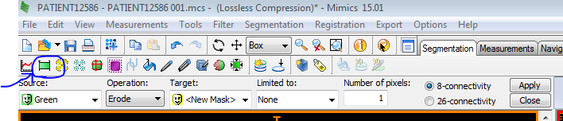
  + Threshold high ~900-3000 so just the part you’re interested in is highlighted (not any residuals). The mask should look like: 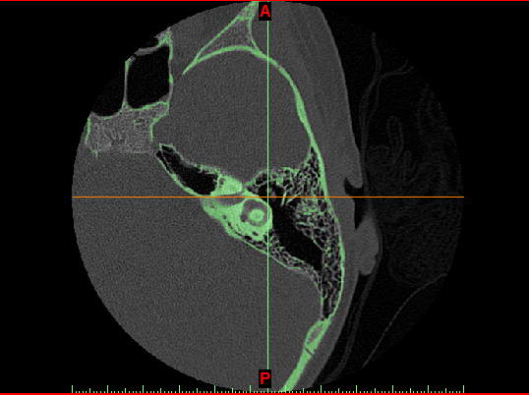
* Right click on the mask on the right bar -> Morphology Operations

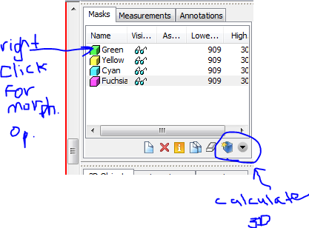

* + Ensure your mask is selected
  + Dilate: select number of pixels – dilates the thresholded region
  + Erode: select number of pixels – erodes parts of the region
  + On the right bar -> calculate 3D model
* Now you have a smooth model but it is missing information because of the dilate
* Edit mask:

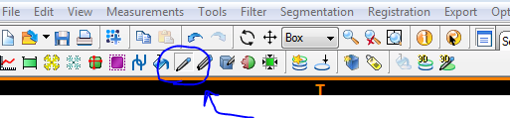

* + Select threshold
    - High range to recover air pockets
    - Low range (~2-3000) to recover structures that were hidden

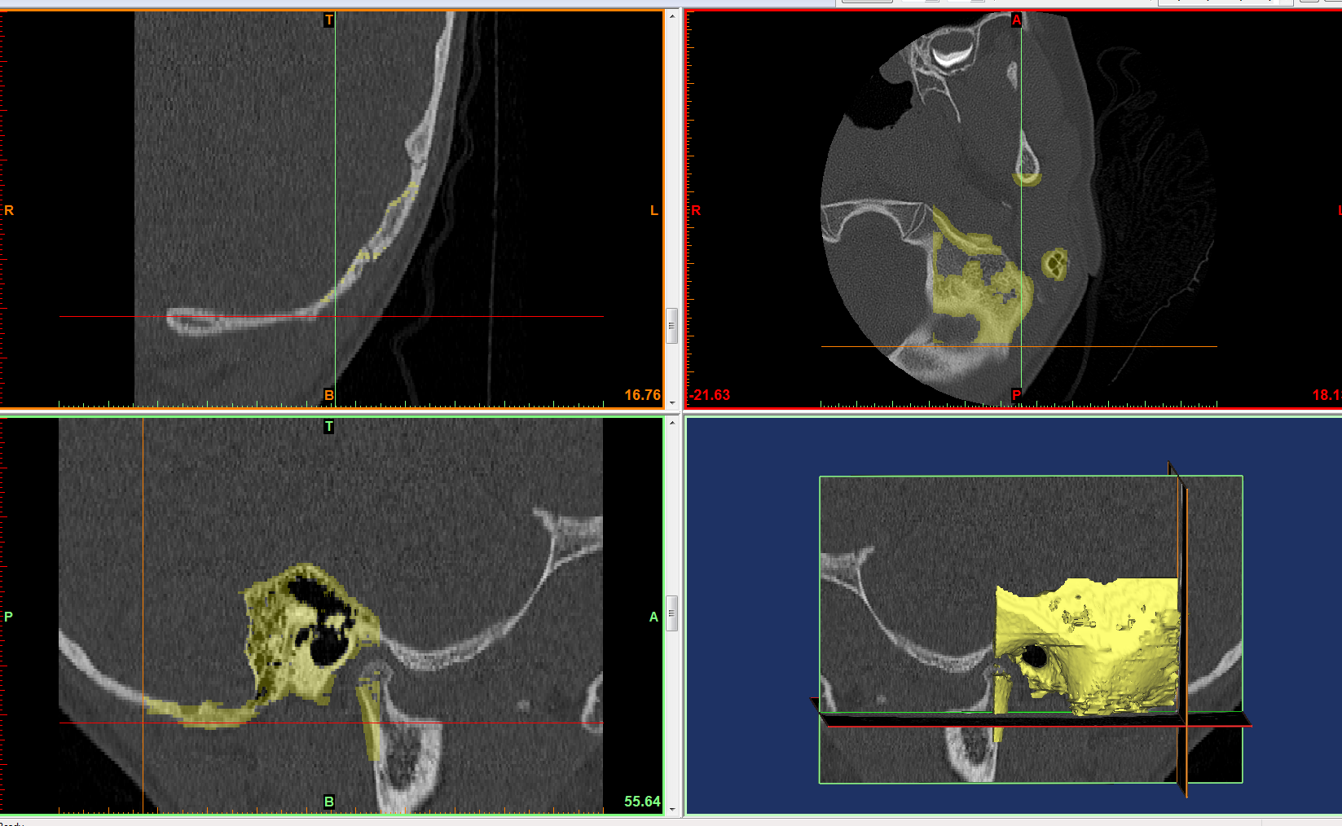

Bottom left shows the ear canal on the scan , bottom right shows the ear canal

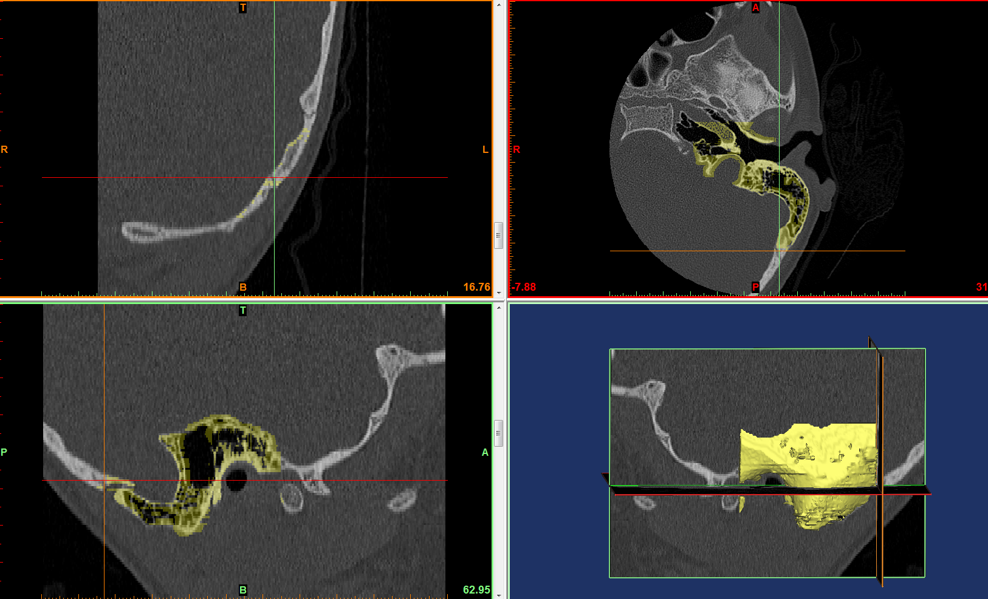

Arrows are pointing to the ear canal – goal is to use the edit mask tool to paint and select the regions with desired threshold

Only are worried about the ear canal as that is where the endoscope and instruments will go through

3D printing of ear model:

V-1 16-Nov-2016:

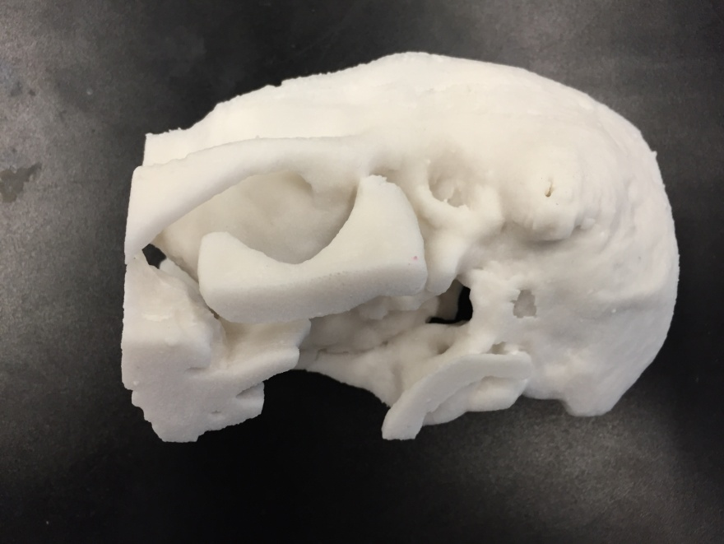

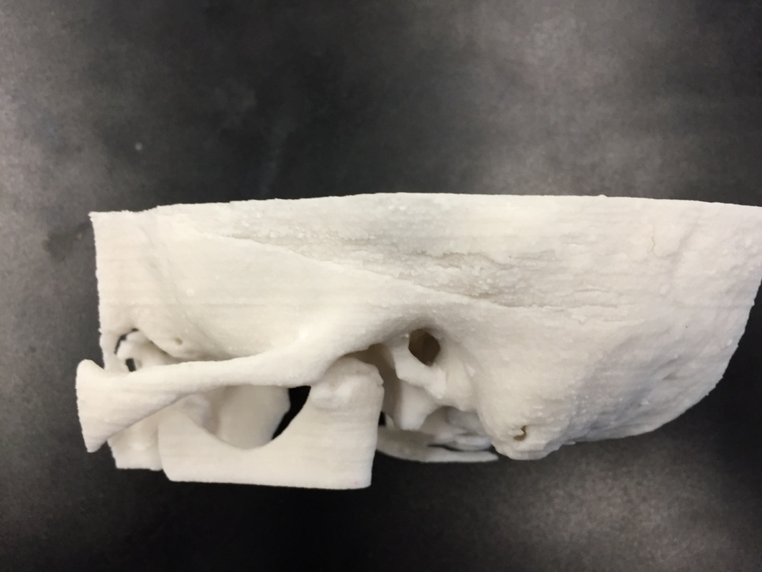

Feedback from Dr. James: Features were blurry – ossicles not visible, usable but not accurate

V-2 22-Nov-2016:

Literature Search on Temporal Bone Models:

* 3D printed ABS temporal bone model